**Jfrog Assignment** 29/06/23

Step 1: Install the Jfrog into the Slave server and select t2.medium

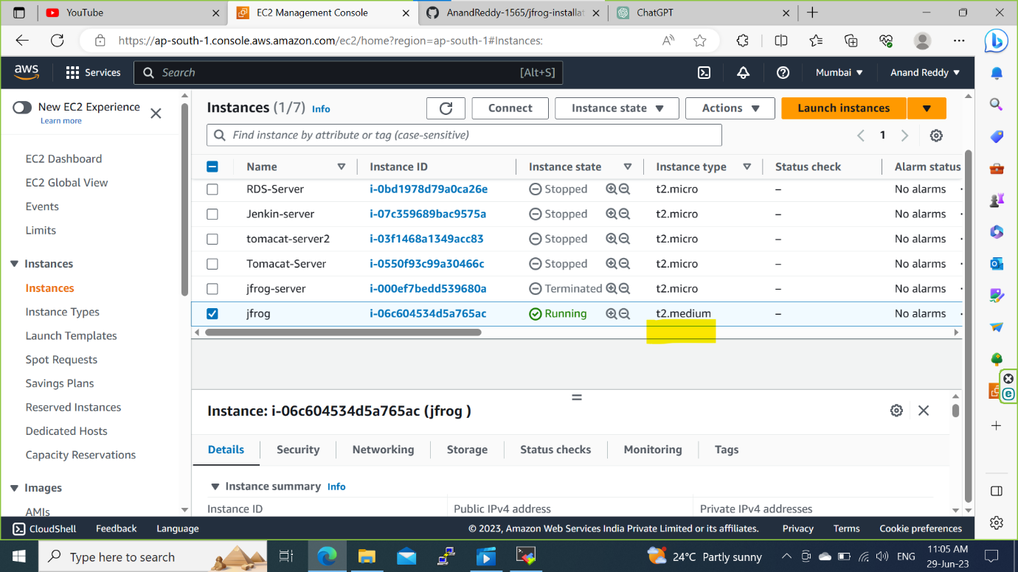

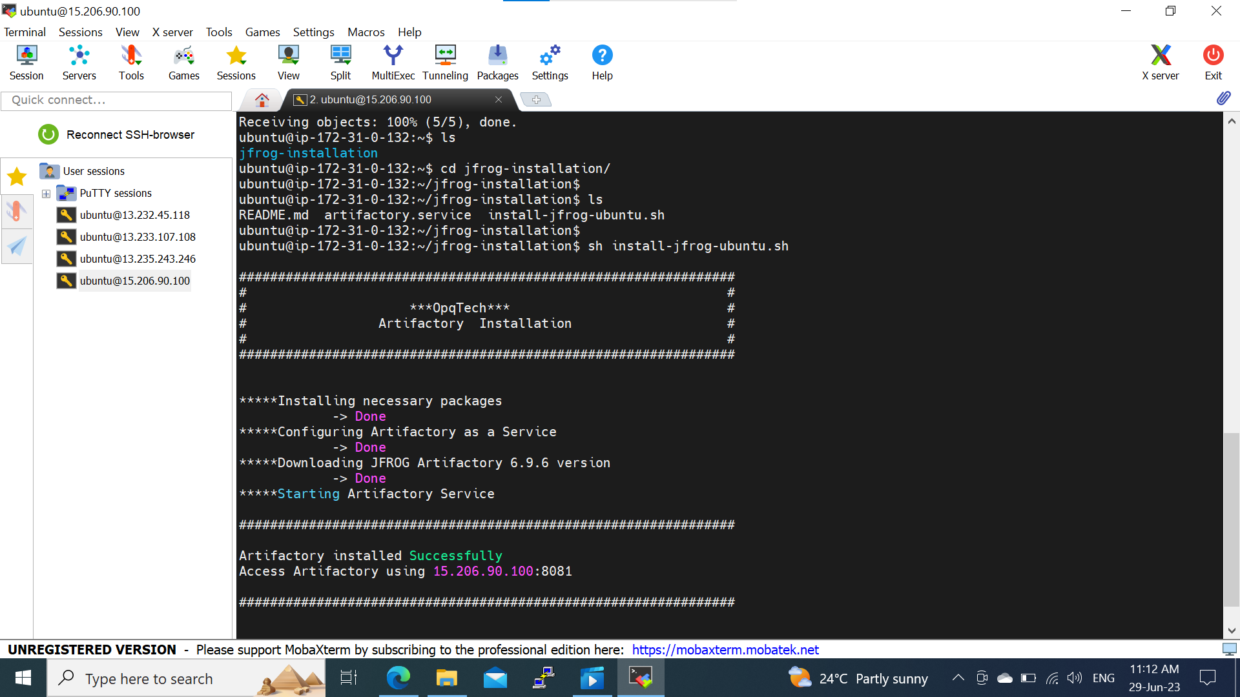

Step 3: open Jfrog Artifactory in Webpage

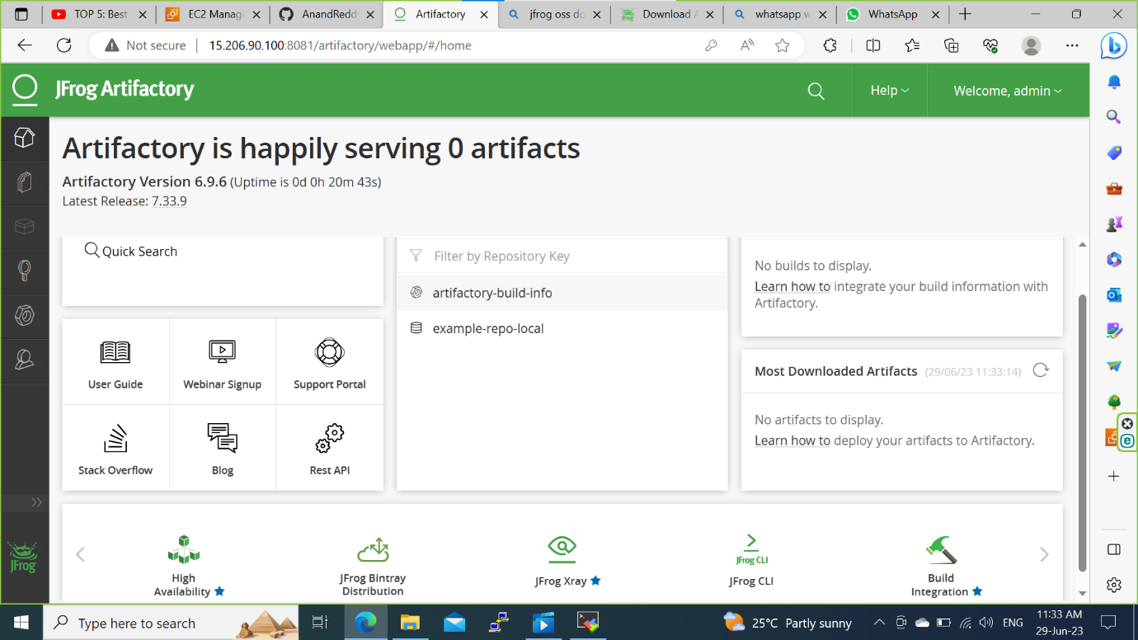

Step 4 : Create a local repository and Name it as Maven

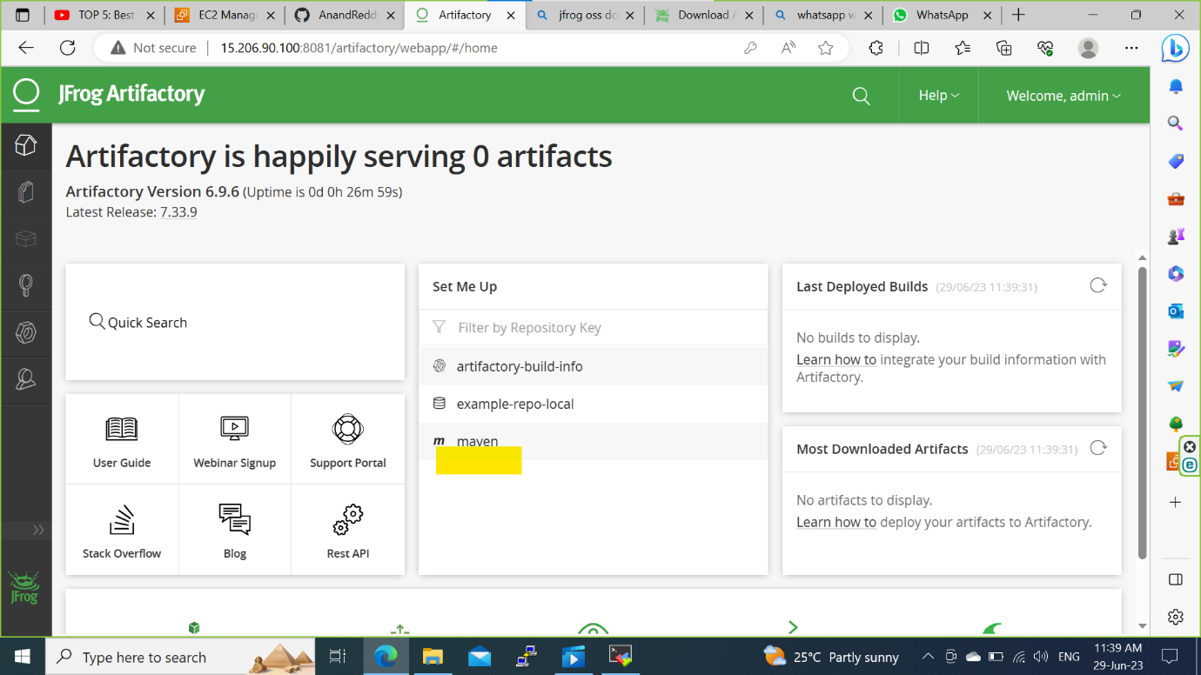

Step 5: create a Jfrog agent node and connect to the Jenkins master.

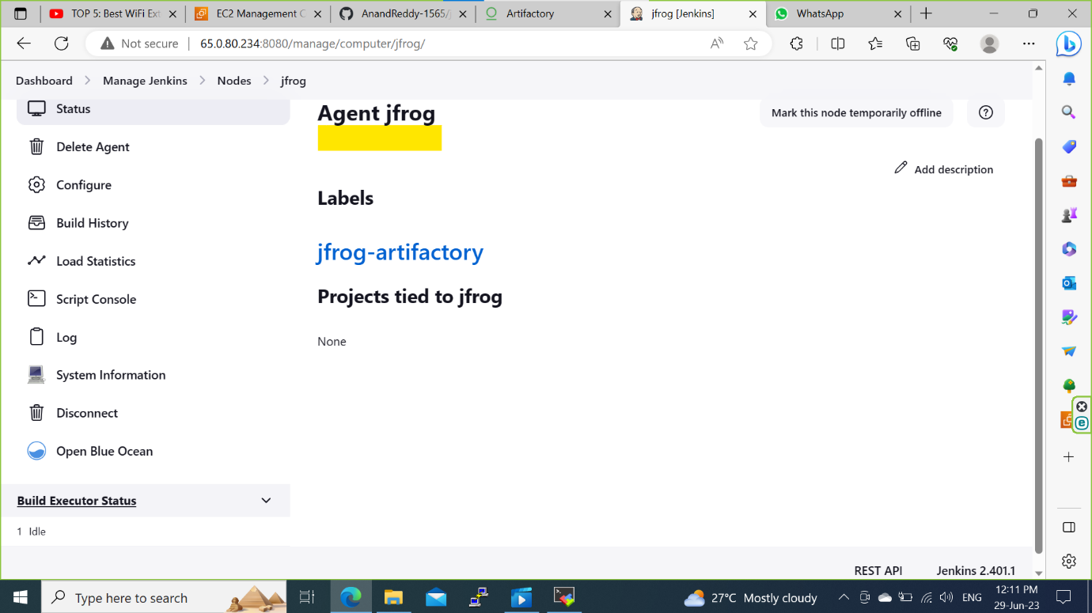

Step 6: Create a New project in Jenkins name it as Jfrog and select maven project.

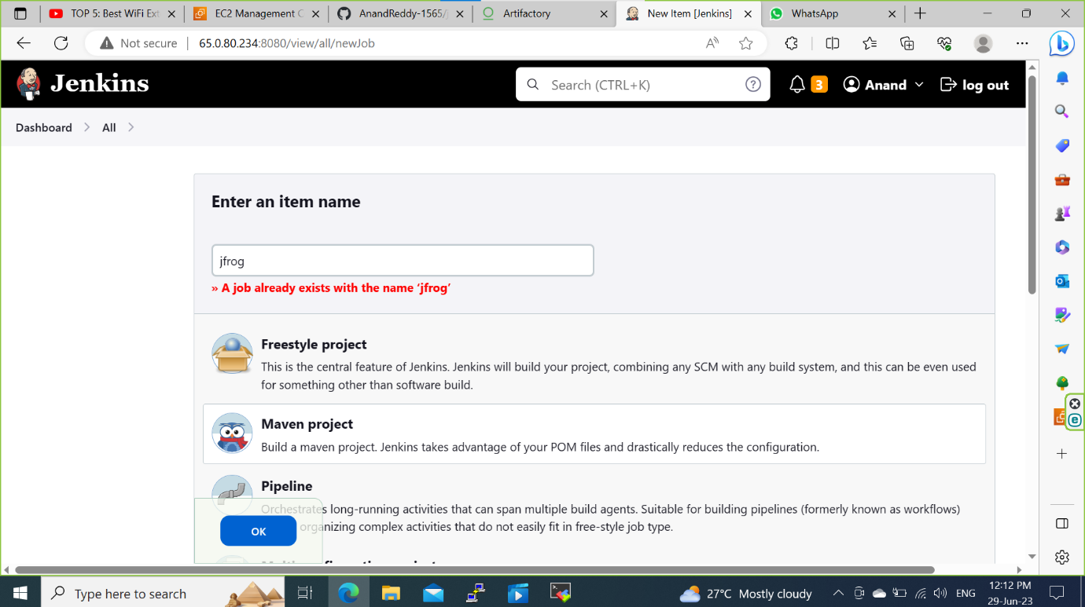

Step 7: Select the created node(jfrog) in restricted this project and copy the git URL to build.

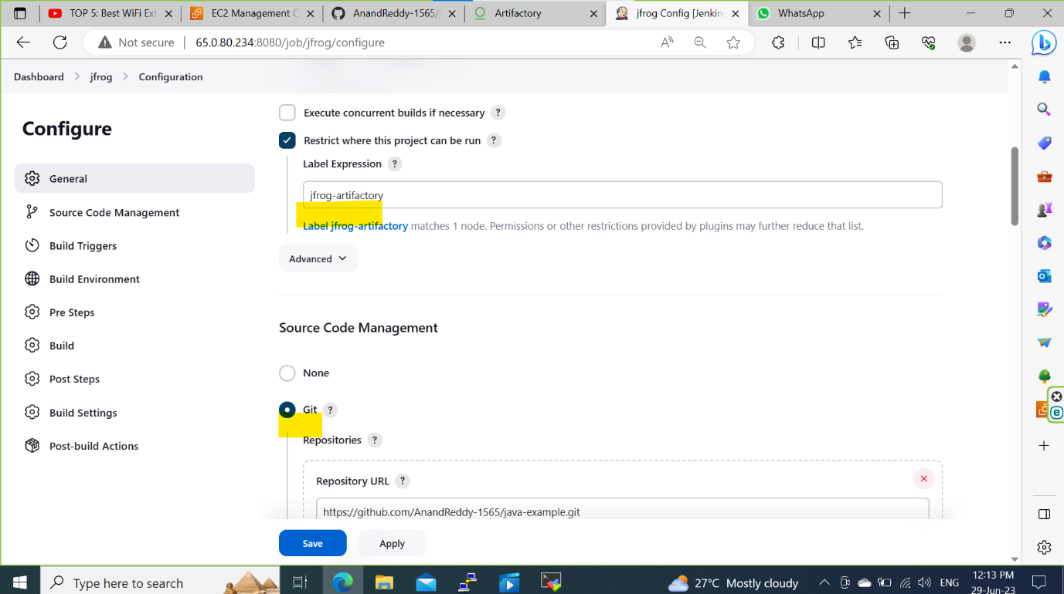

Step 8: Mention the build steps

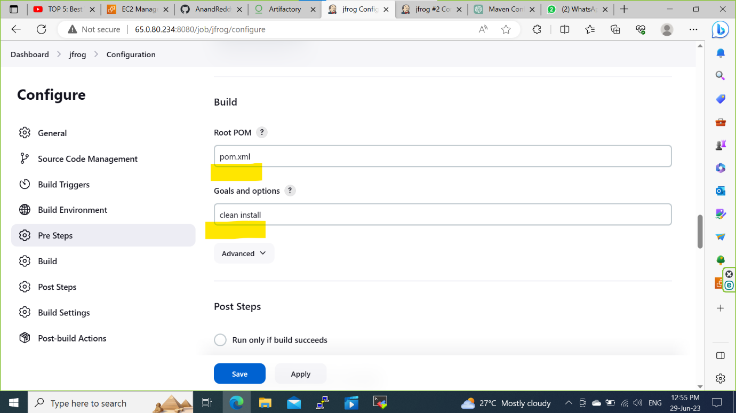

Step 9: In system configuration give Artifactory details with Artifactory port number and credentials of Jfrog Artifactory

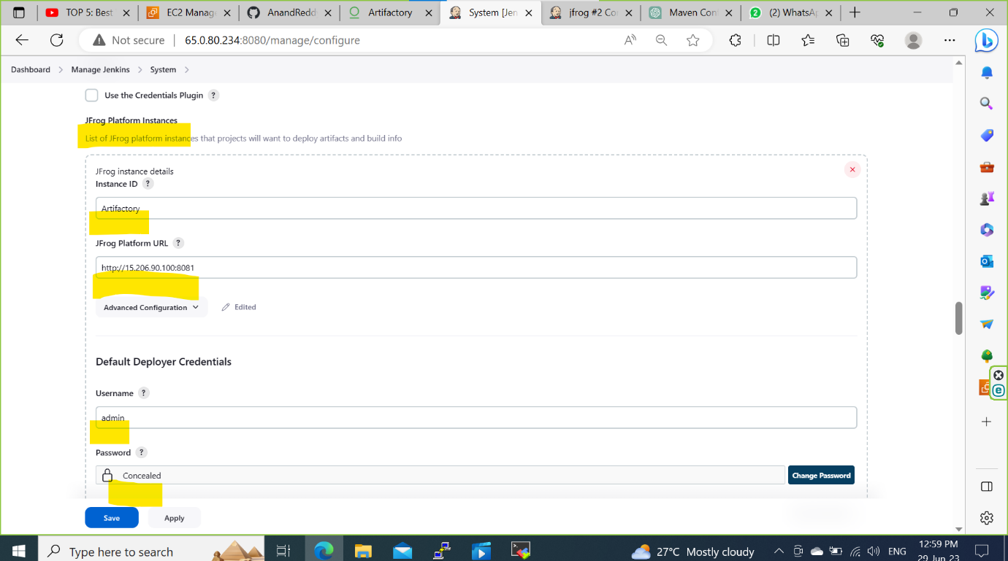

Step 10: click on post build option and select **Deploy artifacts to Artifactory.**

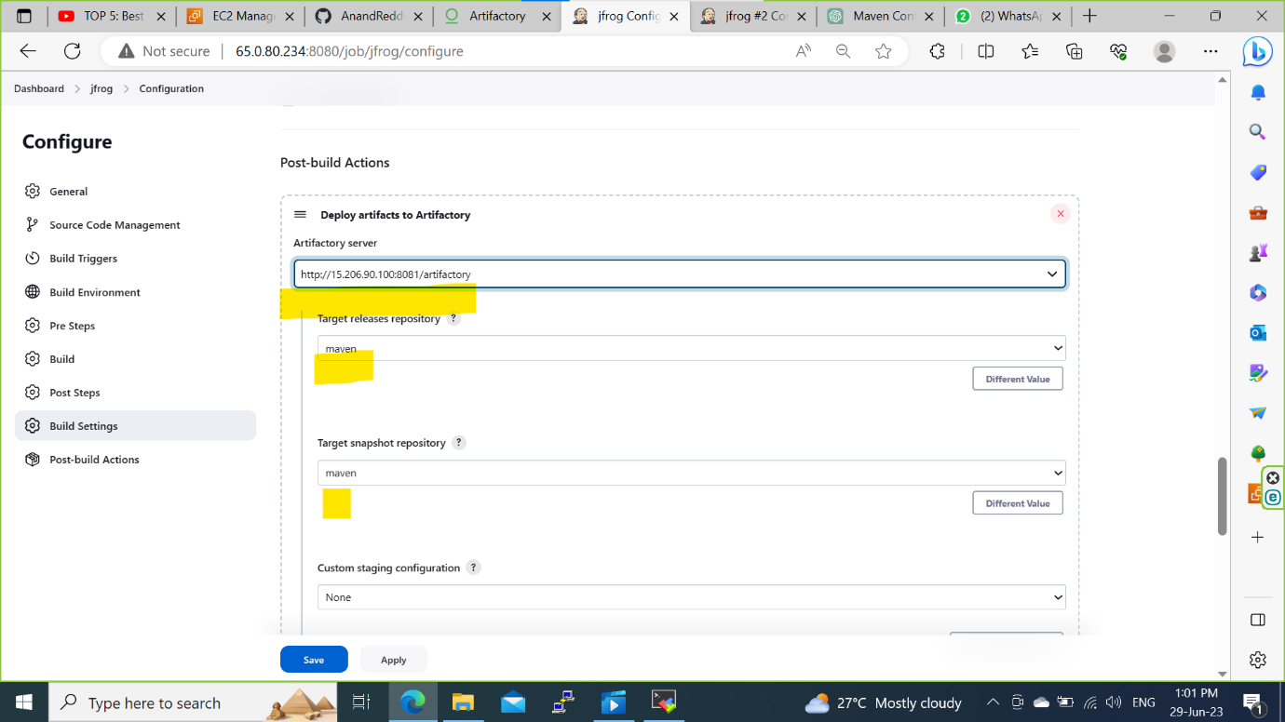

Step 11: Select the Maven Repository to deploy the artifacts into the Jfrog Artifactory.

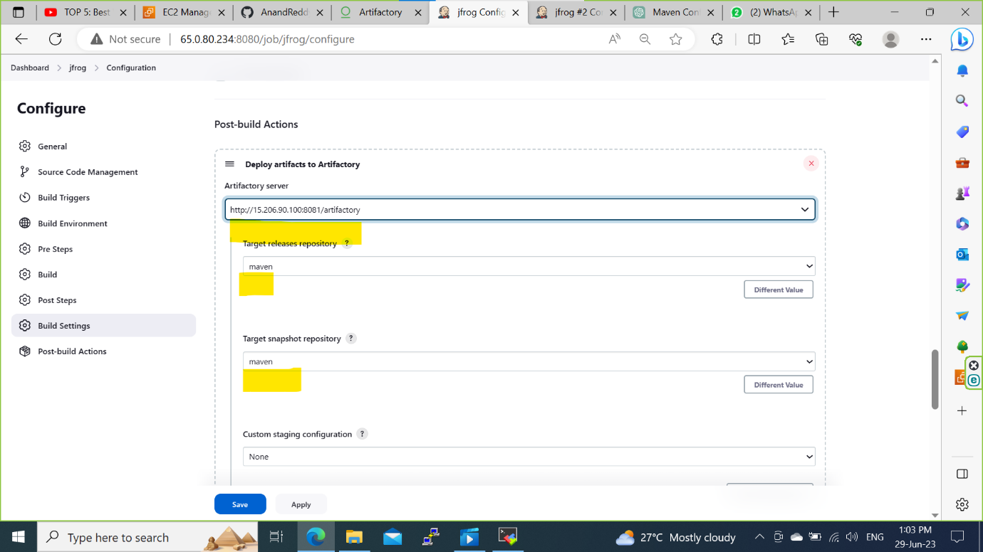

Step 12: Artifacat deployed into the maven repository.

